**Kanetkar Residence Renovations**

Guelph, Ontario

**Architect**  Raminder Kanetkar Architect Inc.

**Project Architect** Raminder Kanetkar

**Year work completed** 2010

**Project Value** $80,000

**Project Description:**

**Gross Floor Area: approx. 400sqft**

This project was truly a labour of love and very personal for Raminder Kanetkar to work on. With her growing family, the old kitchen in the house was becoming dysfunctional, confined and cluttered. The appliances were not energy efficient and the growing (generation X) kids needed more space to hang around the kitchen and the family room. The plan layout for the renovated kitchen was completely changed from a confined u shape kitchen to an arrangement around a 12'-0"X3'-6" island, where everyone could gather and do various tasks. The renovated kitchen, In addition to being a social hub, now accommodates better flow, more people, larger storage space and, with its modern clean lines, gives the feeling of openness and an expanded space.

Raminder lowered the kitchen ceiling to accommodate pot lights, mood lighting fixtures and to hide existing bulkheads. She also paid special attention in selecting environmentally friendly, durable and low maintenance materials for countertops (Caesarstone), flooring (Vermont slate & Maple planks), cabinets (Architectural grade plywood) and backsplash (Back-painted glass). The same materials are carried through to the family room.

For furnishings she invested in a few mid century modern classic furniture pieces such as Wassily Chairs and Eames console tables that her family enjoys using. These classic furniture pieces are functional, will never be outdated, and are conversation starters.

**Unique Design Features:**

Some of the project's unique design features included:

-Caesarstone island used both as work surface and eating area. This material is very easy to maintain, does not stain and is almost indestructible.

-Heated floors in some sections of the kitchen, such as in the eating area and in food preparation area, are a very useful comfort feature. Sun touch electric heating pads were used due to the limited floor depth (1/2"). Thermostat is used to adjust and turn off the heating as required during the seasons.

-Two sinks were installed to accommodate the needs of all four family members working in the kitchen at the same time.

-Variety of storage needs are accommodated by providing a combination of open storage shelves, cabinets with pull out drawers, fixed cabinets with doors, and drawers for pots and pans. The bulkheads are eliminated and cabinets are built to the ceiling space, providing additional storage. A pull out pantry on the side of stove holds all the spices and lentils etc.

-A six (6) burner gas stove with a commercial style hood is appropriate for the family's unique ethnic cooking needs.

**Challenges Unique to the Project:**

The kitchen renovation was done while the family was living in the house. It took about a month to put it all together. Different trades had to be co-ordinated very efficiently in order to finish the work on time which required rigorous pre-construction planning. The family survived through the difficult renovation and enjoys the end result very much.

**Project Involvement/Role:**

Raminder designed and co-ordinated the project very successfully.

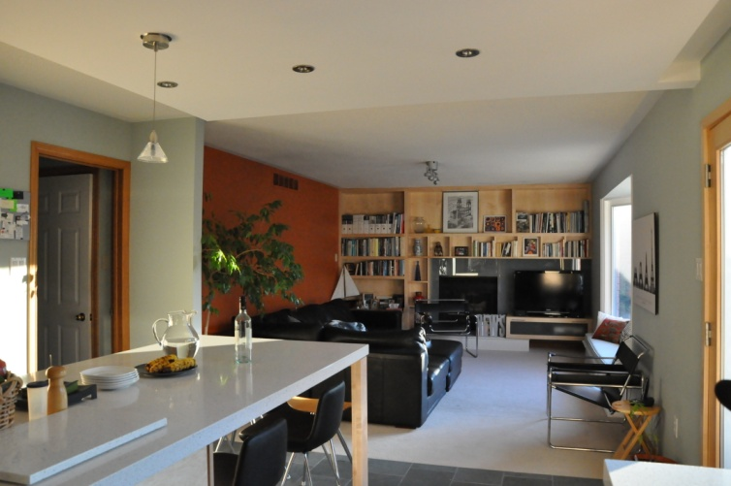 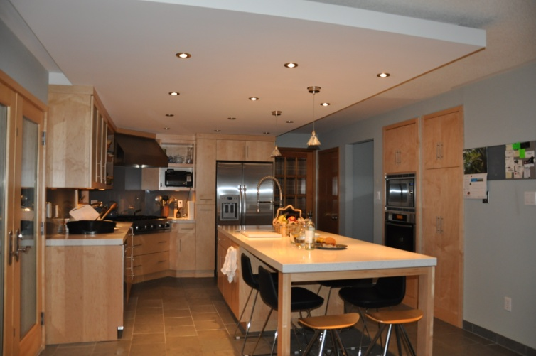

**Family Room Kitchen Is-land**

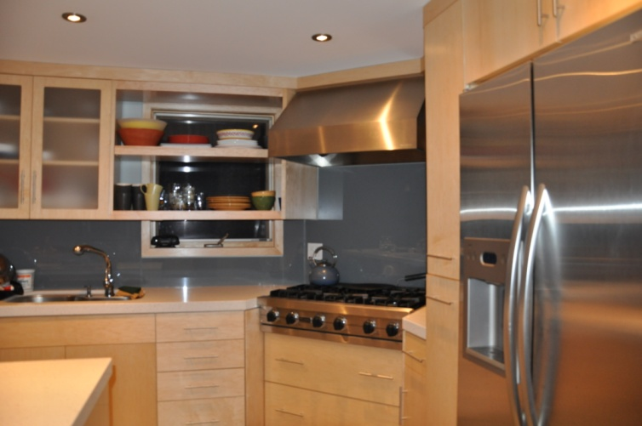 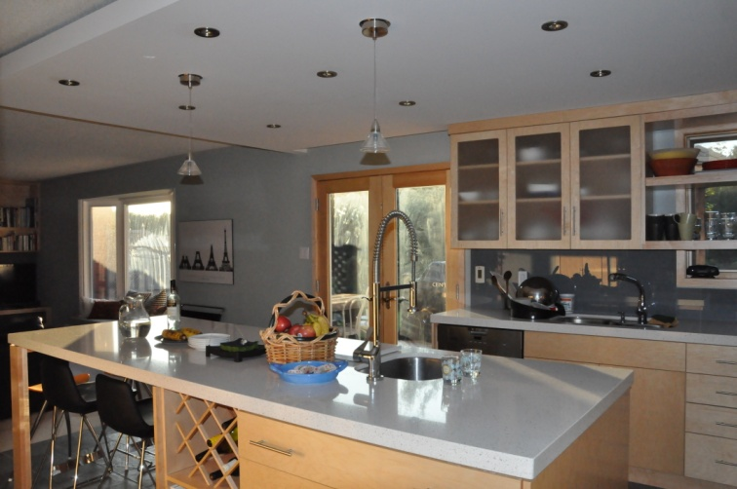

**Kitchen cooking area Storage**